|  |
| --- |
| **National University of Computer and Emerging Sciences** |
| Lab Manual 9  “ASP.net connectivity with Database” |
|  |
| Database Systems |
| Spring 2018 |

Department of Computer Science

FAST-NU, Lahore, Pakistan

**Table of Contents**

1. Objective 2

2. Prerequisites 2

3. Task Distribution 2

4. Three Layer Architecture 3

Presentation Layer (UI) 3

Business Access Layer (BAL) or Business Logic Layer 3

Data Access Layer (DAL) 3

5. Getting Started 4

6. Presentation Layer (UI) 4

7. Date Access Layer (DAL) 6

Business Access Layer (BAL) 11

8. Execute your Project (Ctrl+f5) 12

# Objective

The purpose of this lab is to give you introduction to ASP.Net three tiered web application and give you understanding of how to create dynamic web pages based on data stored SQL server database. We will get introduced with data controls available in asp.net 3.5 framework to display and interact with data dynamically.

# Prerequisites

Before this lab you should know how to create ASP.net web project, how to create new aspx Web Form. You should also read about 3 tier architecture from text book Elmasri.

# Task Distribution

|  |  |
| --- | --- |
| Total Time | 170 Minutes |
| Introduction | 20 Minutes |
| GUI | 30 min |
| DAL | 40 min |
| BAL | 30 min |
| Evaluation | 30 Min |

# Three Layer Architecture

Three-tier is a client-server architecture in which the user interface, functional process logic ("business rules"), data storage/data access are developed and maintained as independent modules/layers.

Each layer (presentation, application, and database) may run on separate machines.

## Presentation Layer (UI)

Presentation layer contains pages like .aspx where data is presented to the user or input is taken from the user.

## Business Access Layer (BAL) or Business Logic Layer

BAL contains business logic, validations or calculations related with the data, if needed.

## Data Access Layer (DAL)

DAL contains methods that helps business layer to connect the data and perform required action, might be returning data or manipulating data (insert, update, delete etc.).

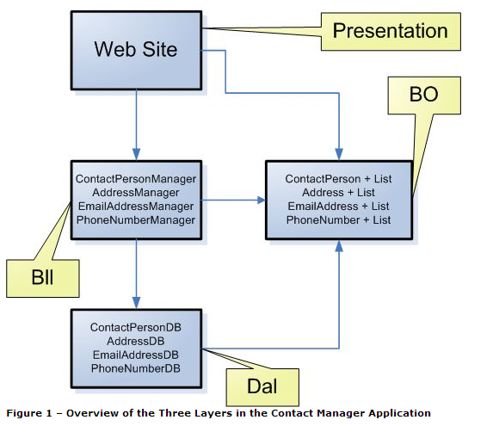

# Getting Started

First step will be to create a web application and add aspx Webform in it i.e. Presentation Layer, then we will create DAL i.e data access layer. After that we will create BAL to connect the DAL and GUI.

For this lab we will use Students Database given in StudentsDB.script file. We will create a simple StudentSearch web page that will take a name as an input and return all the students with that name.

# Presentation Layer (UI)

### UI Step 1:

Create and ASP.net web application and add a new web form ‘SearchStudent’ in it. As shown in figure.

This page has one text box in which student name will be entered. A search button, and a GridView. Grid view will show the result (student with search name) in form of table, label control will show if any student is found or if there was any error.

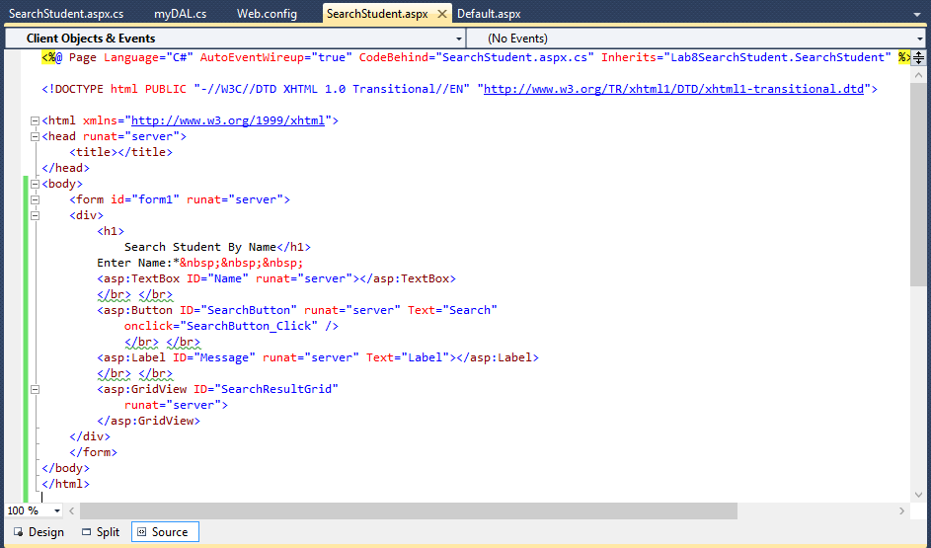

Figure 1: SearchStudent aspx page

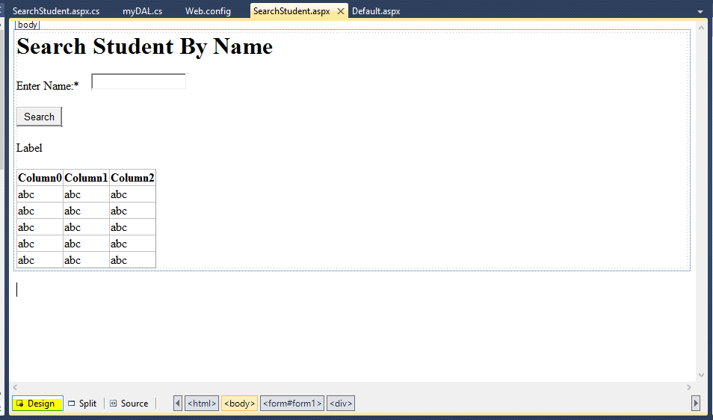

Figure 2: StudentSearch in Design View

# Date Access Layer (DAL)

In DAL you access the data from database so first step is to connect the database with website.

### DAL Step 1:

Database Connectivity: Go to Solution Explorer and open Web.config file.

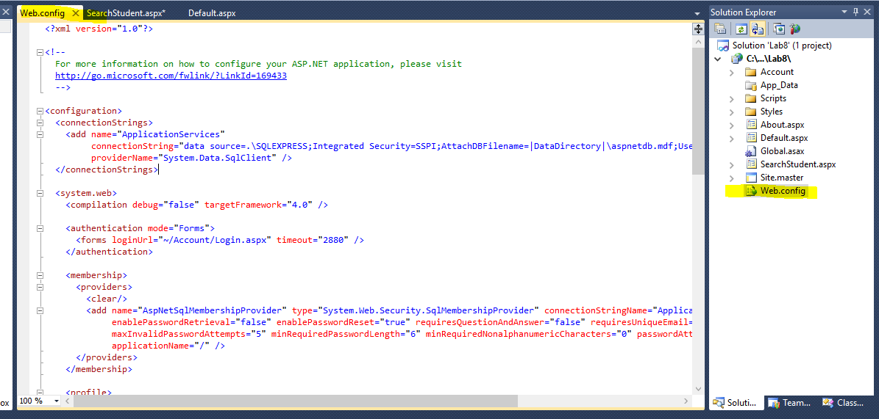

Figure 3 Web.Config file

### DAL Step 2:

Specify server name, use name, password and database name of your database in this Web.Config file via Connection String, as shown in figure.

NOTE: Make sure you have create your student database on lab server or on your own laptop, also create SearchStudentByName procedure as given SearchStudentByName_Procedure.script file.

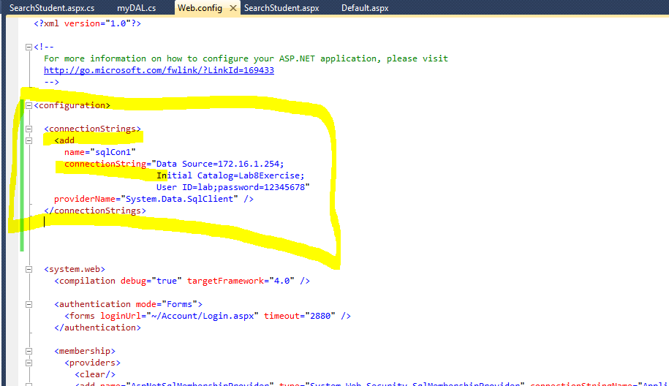

Figure 4: ConnectionString of you database in WebConfig File

*What does connection String means?*

Connection string is used to specify the username server name password and database name of the database you want to retrieved data from

*What are these attributes of Connection String?*

Following figure shows what the attributes of connection string are and how to obtain them.   
First one is connection Name, second is server name database name username and password.

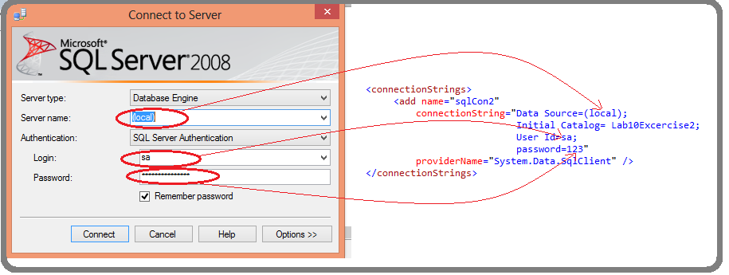

*What if I am using windows authentication mode?*

For windows auth. Mode your connection string will look like following figure, it will note specify usename and password, and it will have Integrated security=True

<connectionStrings>

<add

name="sqlCon1"

connectionString="Data Source=(local);Initial Catalog=Lab10Excercise2;Integrated Security=True"

providerName="System.Data.SqlClient" />

</connectionStrings>

NOTE: Follow all the spaces as give in figures and avoid typos.

### DAL Step 3:

Add new folder in you project named *DAL*. Then add *myDAL.cs* file, of type CLASS Visual C#, in that folder. (As shown in figure)

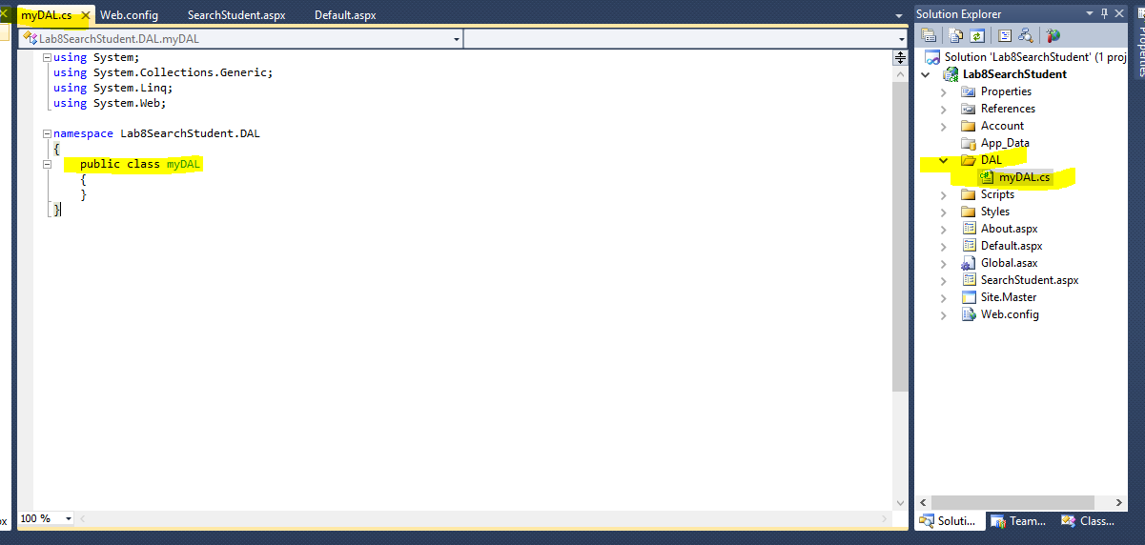

Figure 5myDAL.cs file

### DAL Step 4:

Add the Reference to Connection String in myDAL.cs file. Also add Name Spaces for SQLclient and DataSets as shown in figure.

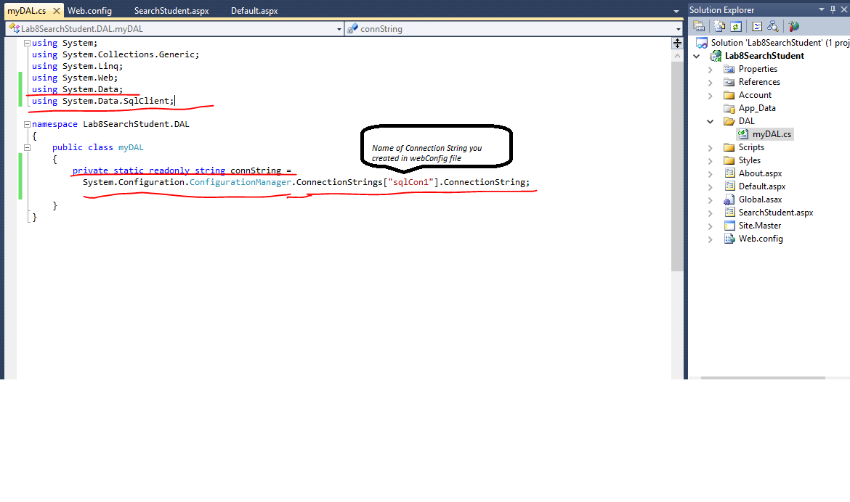

### DAL Step 5:

Create a SearchStudentbyName_DAL function in myDAL class (as shown in figure and given in SearchStudentByName_DAL function.txt file). This function will take name as input and call the SQL procedure SearchStudentbyName and return the resulting table.

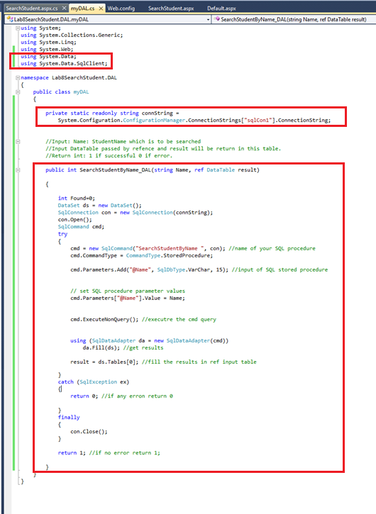

Figure 6 SearchStudentByName_DAL function

# Business Access Layer (BAL)

In BAL you will connect GUI with DAL, this layer includes working with aspx.cs files.

### BAL Step 1:

Open SearchStudent.aspx file and set onclick="SearchButton_Click" property of Search Button, as shown in figure.

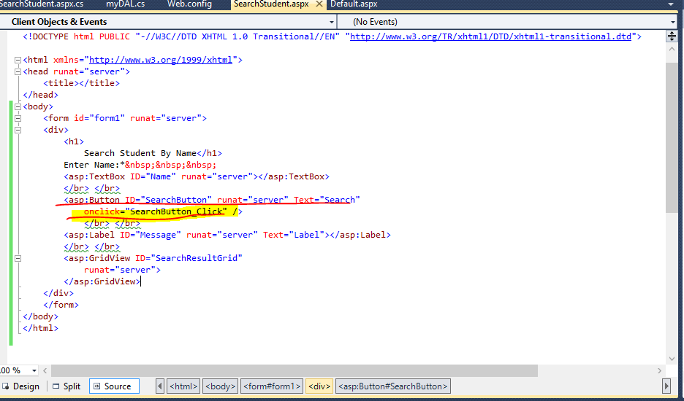

### BAL Step 2:

Now we will create SeachButton_Click function in SearchStudent.aspx.cs file, this function will be called whenever Search button is pressed.

Add name space DAL, and DATA to SearchStudent.aspx.cs file, and create the function (This function is also given in SeachButton_Click_function.txt file)

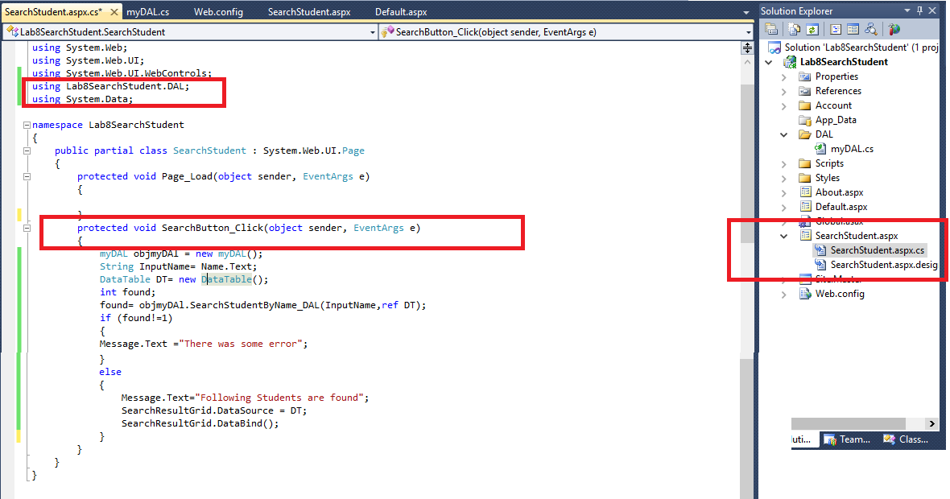

# Execute your Project (Ctrl+f5)

Your project should look like following figure

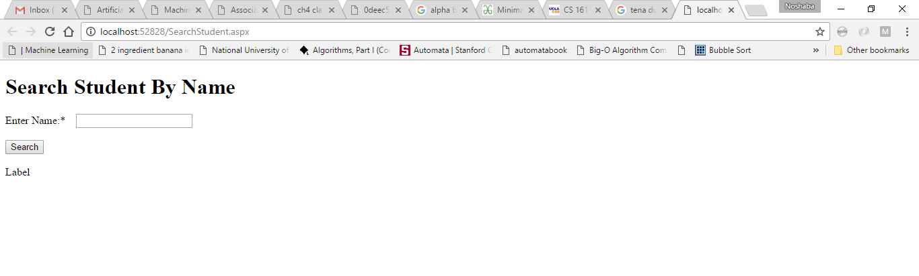

Search using keyword and results should be populated in Grid

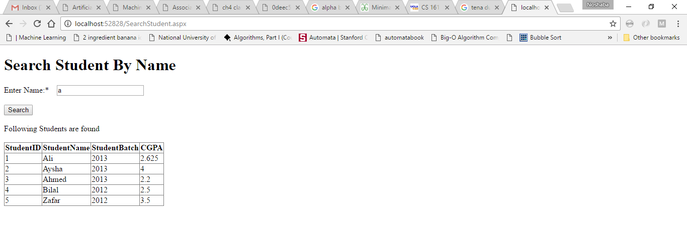

# Exercise:

Modify the above project, such that the label should show the number of students found in search query.

For example if you search “*a” you* should get following results as shown in figure (7), if no student found it should show ‘No student found’ as shown in figure (b). This number of students found should be returned by SQL stored procedure, as an output parameter.

You have to work on how to get and use the output parameter returned from SQL procedure in DAL layer and then in BAL layer to display on GUL layer.

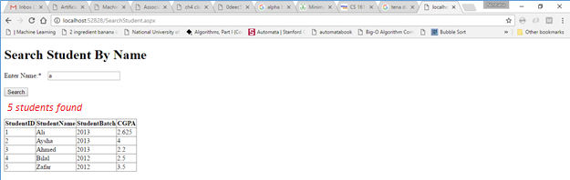

Figure 7

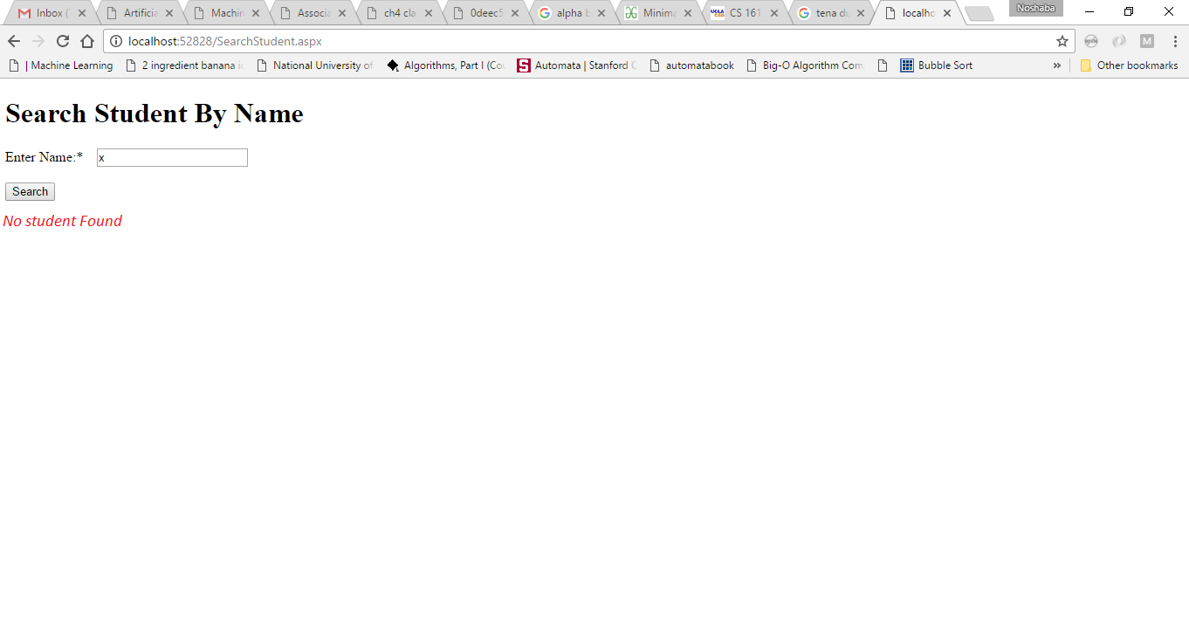

Figure 8